- Hyper link the logo
- Menu Changes
- Home
- About Us
- Services
  - Technology => PHP, Android, Wordpress, Joomla, Drupal, Woo-Comemrce,Andriod, IOS
  - Industry = > Education, Hospitality, Business Management
- Works
  - Website Development
  - Software Development
  - E-commerce Development
  - Mobile App
  - Online Promotion
  - Mobile App Promotion
- Product
- Contact
- Copy contnet from https://www.webapplicationbybigwigmedia.com/

- After Banner there will be our services
- Website Development
- WebApplication
- Ecommerce
- Mobile App
- WebHosting and Security
- Online Promotion/360 Dgree Digital Marketing

Then add 4 sections like below
- Three section are a)Website/WebApplication b) Mobile App c) Digital Marketing d) WebHosting, domain and Security

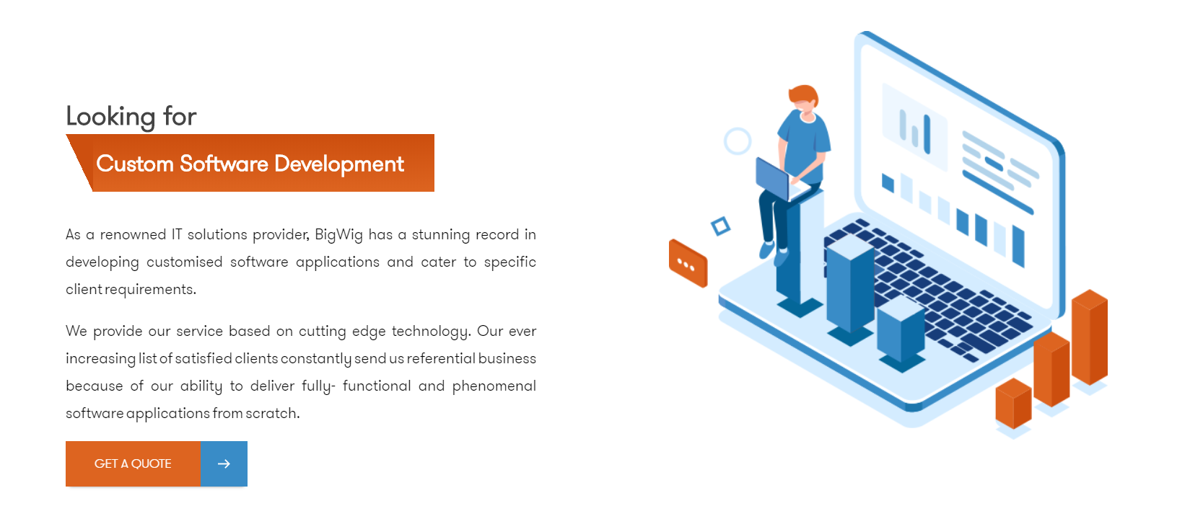

There will be a sticky side to get enquiry.

